Logging into Nettrekker

You can use Nettrekker in one of two ways. 1) As a search engine. The best part of Nettrekker is that it is peer reviewed, so the information given to you from these web-sites is accurate. Also you will receive far less hits then if you were to use google. 2) As a location to read web-sites that a teacher has placed into a folder for you to use. This handout will teach you how to log in and access the pre-arranged folders.
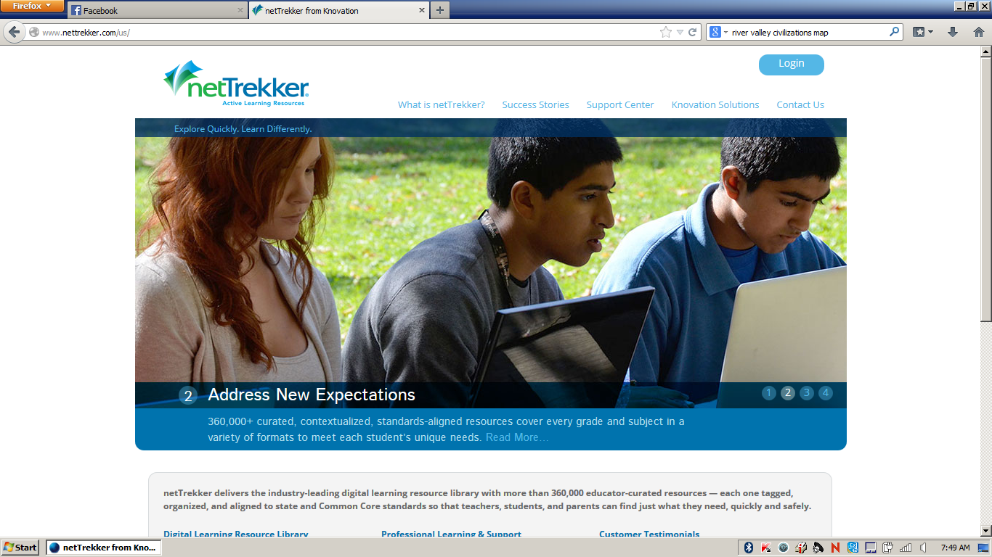
Step 1) Go to www.nettrekker.com , in the upper right hand corner you will see a button called login. This will take you to the login part of the site.
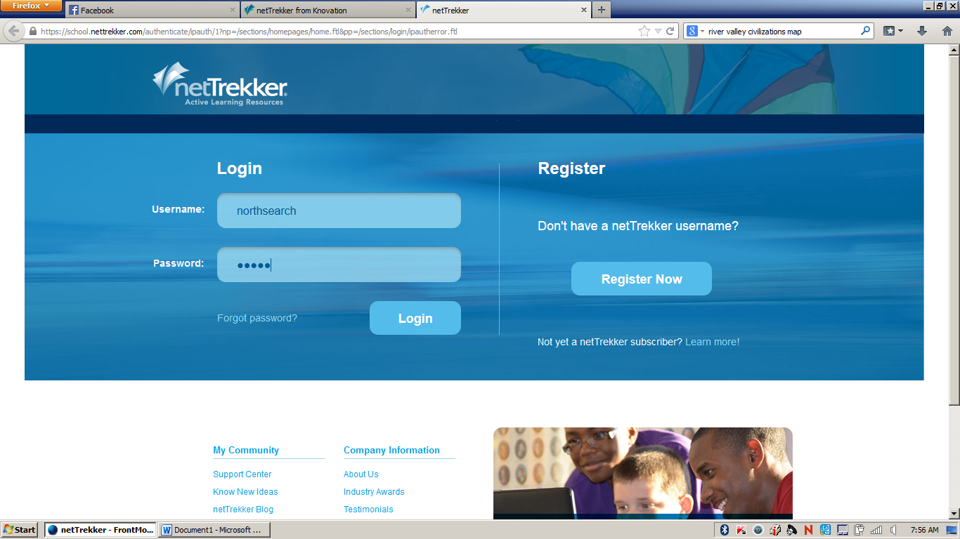
Step 2) username: northsearch password: north
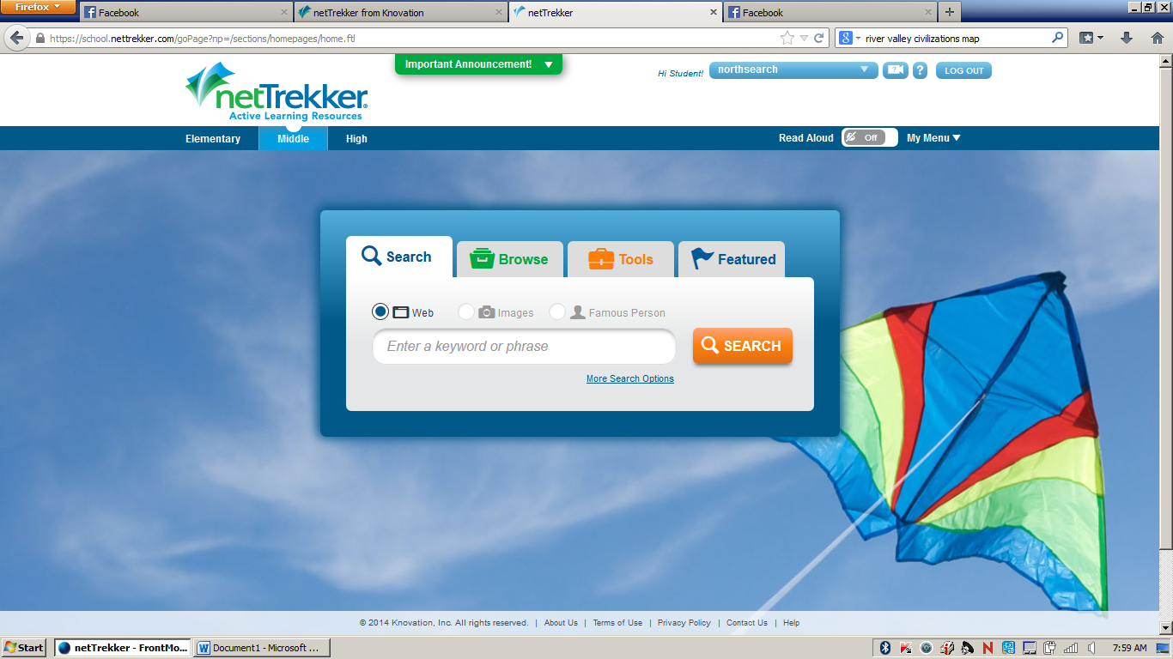
This is where you can use Nettrekker as a search engine or continue on to the teacher folders
Step 3) Click on “my menu” found below log out in the upper right hand corner. When you click on “my menu” it will open a tab called “my portfolio” click here.

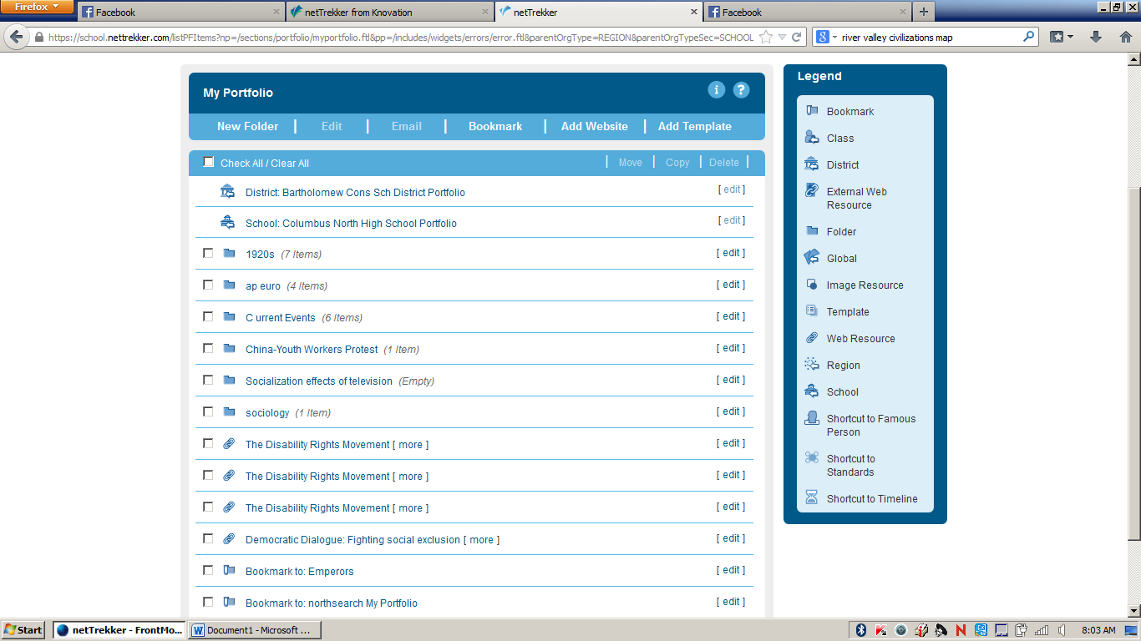
Step 4) Click on the link School: Columbus North High School Portfolio
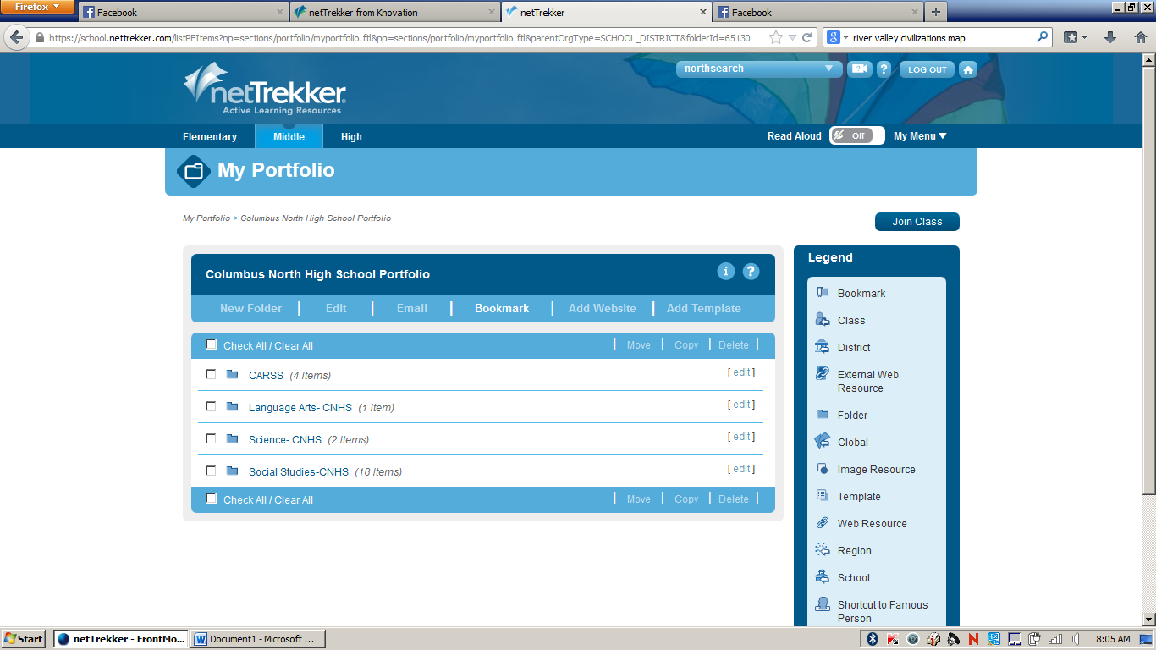
Step 5) Click on the link: Social Studies
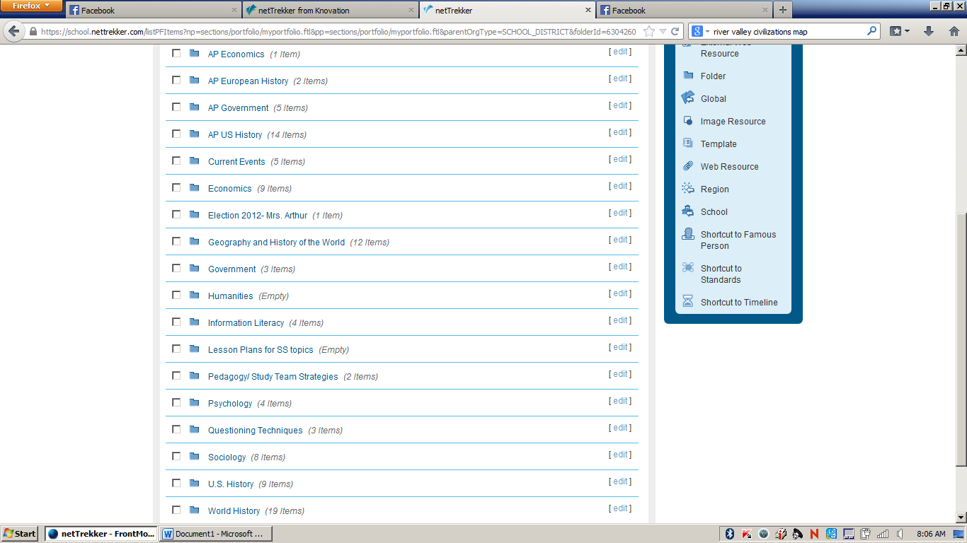
Step 6) you will get to the page with Links for all the social studies classes. They are found in alphabetical order. Once you click on the course, it will take you to many folders, one per unit of study in this course.

